Rossmoyne SHS

Trial WACE Examination, 2010

Question/Answer Booklet

MATHEMATICS 3A/3B(1)
SOLUTIONS

Section One:

Calculator-free

Student Number: In figures

In words

Your name

Time allowed for this section
Reading time before commencing work: 5 minutes
Working time for paper: 50 minutes

Material required/recommended for this section

To be provided by the supervisor
This Question/Answer booklet
Formula sheet

To be provided by the candidate
Standard items: pens, pencils, pencil sharpener, eraser, correction fluid, ruler, highlighters

Special items: nil

Important note to candidates

No other items may be used in this section of the examination. It is your responsibility to ensure that you do not have any unauthorised notes or other items of a non-personal nature in the examination room. If you have any unauthorised material with you, hand it to the supervisor before reading any further.

Structure of this paper

Section | Number of questions available | Number of questions to be answered | Working time (minutes) | Marks available
Section One:  Calculator-free | 7 | 7 | 50 | 40
Section Two:  Calculator-assumed | 12 | 12 | 100 | 80
 |  |  |  | 120

Instructions to candidates

- The rules for the conduct of Western Australian external examinations are detailed in the Year 12 Information Handbook 2010. Sitting this examination implies that you agree to abide by these rules.

- Write your answers in the spaces provided in this Question/Answer Booklet. Spare pages are included at the end of this booklet. They can be used for planning your responses and/or as additional space if required to continue an answer.
- Planning: If you use the spare pages for planning, indicate this clearly at the top of the page.
- Continuing an answer: If you need to use the space to continue an answer, indicate in the original answer space where the answer is continued, i.e. give the page number. Fill in the number of the question(s) that you are continuing to answer at the top of the page.

- Show all your working clearly. Your working should be in sufficient detail to allow your answers to be checked readily and for marks to be awarded for reasoning. Incorrect answers given without supporting reasoning cannot be allocated any marks. For any question or part question worth more than two marks, valid working or justification is required to receive full marks. If you repeat an answer to any question, ensure that you cancel the answer you do not wish to have marked.

- It is recommended that you do not use pencil except in diagrams.

Section One: Calculator-free (40 Marks)
This section has seven (7) questions. Answer all questions. Write your answers in the space provided.

Working time for this section is 50 minutes.

Question 1 (5 marks)
The number of telephone calls answered per hour in an office over a survey period of 22 hours is shown in the table below.

Number of calls | 0 | 1 | 2 | 3 | 4 | 5 | 6
Frequency | 1 | 4 | 6 | 5 | 3 | 1 | 2

(a) Construct a median boxplot for this data. (3 marks)
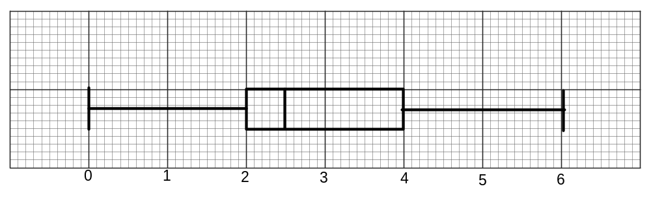
3 marks [lose 1 mark for each major point incorrect]

(b) Use the boxplot to explain whether the mean number of telephone calls answered per hour would be higher than, lower than or the same as, the median. (2 marks)

The boxplot is skewed to the right as the lower 50% of data is between 0 and 2.5 whereas the upper 50% of the data is between 2.5 and 6. So the mean will be higher than the median.

2 marks [1 mark for correct answer; 1 mark for reasoning
No marks if answer incorrect]
(a) Too many students did not know what a median boxplot was!!
(b) once boxplot drawn, interpretations were good
Question 2 (6 marks)
(a) Expand and simplify with positive indices 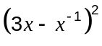. (2 marks)
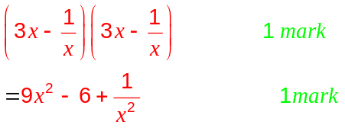

Common error was 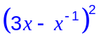 = 9x² - 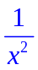

(b) The curve 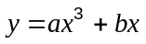 has a stationary point at (1, -4).
Find the values of and . (4 marks)
Substitute (1, -4)
-4 = a + b (eqn 1) 1 mark

Differentiate and substitute
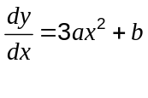
0 = 3a + b (eqn 2) 1 mark
Solve simultaneously
2a = 4 (eqn 2 – eqn 1)
a = 2 1 mark
b = -6 1 mark
Those who correctly obtained the two equations could solve them. Too many students didn’t get equation (1)

Question 3 (5 marks)
A universal set 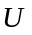has two subsets, 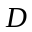 and 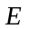such that 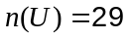, 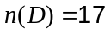, 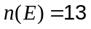 and 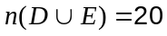.
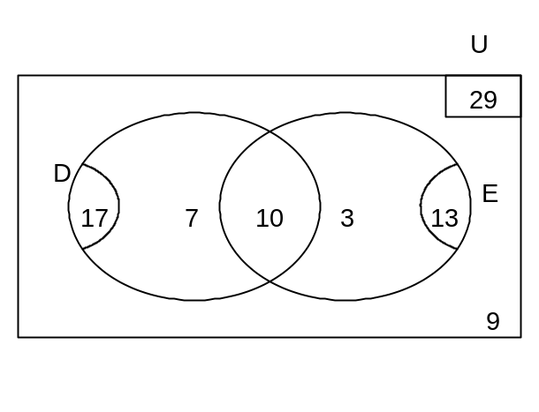
(a) Show this information using a Venn diagram. (2 marks)

Part (a) well done

2 marks -1 each mistake; f.t.
(b) Calculate

(i) 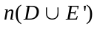 (1 mark)
26

A common answer was 16, which meant part of D was omitted

(ii) 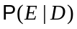 (1 mark)
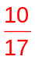

Some students gave P(DIE)

(c) 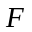 is a third subset of and is such that 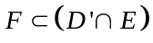. State all possible values for 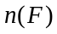.
(1 mark)
0, 1, 2 or 3

Many students gave only one answer viz: 3
F is a subset of 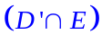, so may not necessarily contain all 3 elements.

Question 4 (7 marks)
The diagram shows the graph of 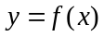.
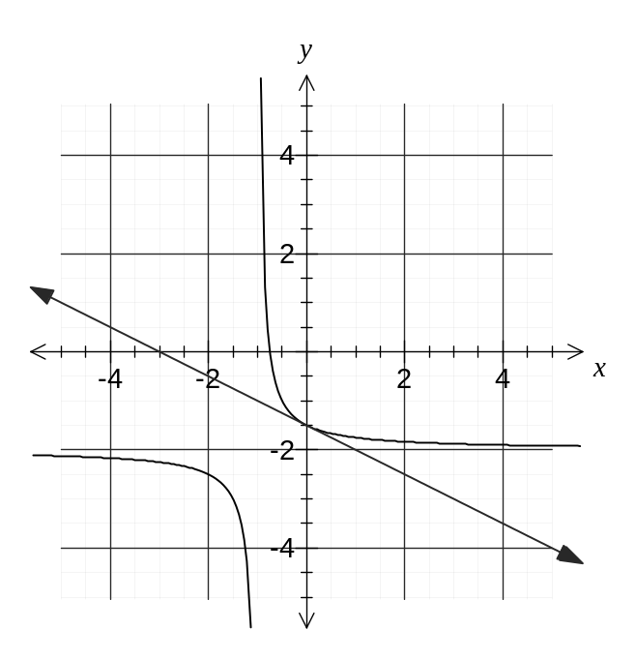
(a) State the equation(s) of the asymptote(s) for the graph of . (1 mark)
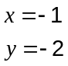

(b) For what values of does the graph appear to be concave up? (1 mark)
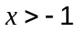

(c) How many lines of symmetry does the graph of have? (1 mark)
2 lines of symmetry
(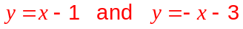)

(d) Draw the tangent to the graph of when 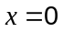 and hence estimate the value of 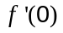. (2 marks)
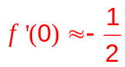

1 mark graph, 1 mark value
(e) State the domain and range of . (2 marks)
Domain: 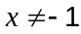
Range: 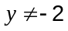

1 mark domain, 1 mark range
Question 5 (8 marks)
(a) Five different books are piled randomly on top of each other on a table. If the authors of the books are Keats, Byron, Adams, Pope and Thomas determine the probability that

(i) the book by Pope is at the bottom of the pile. (1 mark)


(ii) the books by Keats and Byron are together at the top of the pile. (1 mark)

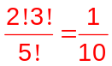

(iii) the books by Thomas and Adams are not together. (2 marks)
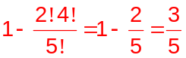

1 mark idea of complement, 1 mark answer

Part (a) well done, although some students gave the number of ways rather than the probability

(b) The lengths of a brand of wooden posts follow a normal distribution with a mean of 179cm and a standard deviation of 4cm. Determine the probability that a randomly chosen post is longer than 175cm given that it is less than 183cm. (4 marks)
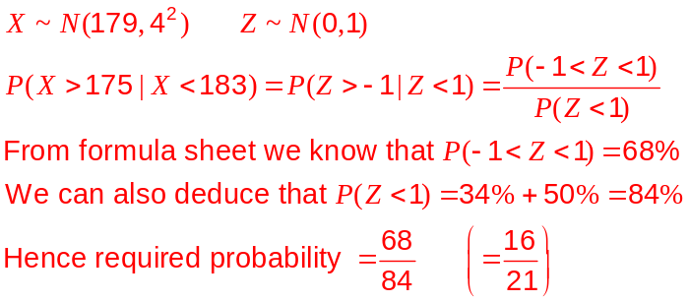

1 mark

1 mark
1 mark
1 mark
It appeared that many students did not use the percentages given on the formula sheet
Question 6 (5 marks)
(a) A curve has equation 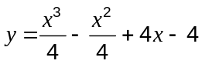. Find the equation of the tangent to this curve at the point (2, 5). (3 marks)

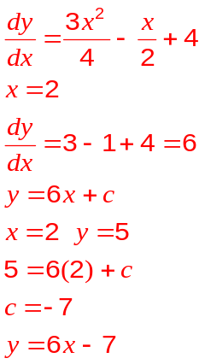

1 mark

1 mark

1 mark

Part (a) - most students found the gradient. Fewer could find the y intercept.

(b) If 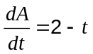 and when 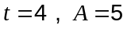, find an expression for in terms of . (2 marks)

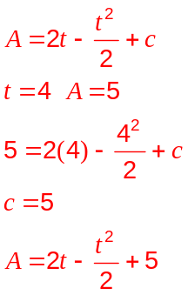
1 mark

1 mark
While most students could do the antidifferentiation, few could find c
Question 7 (4 marks)
The graph shows the function 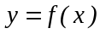.
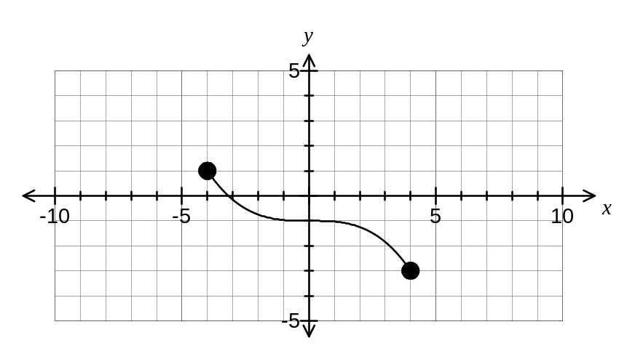

(a) The graph below shows the function 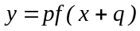. State the values of p and q. (2 marks)
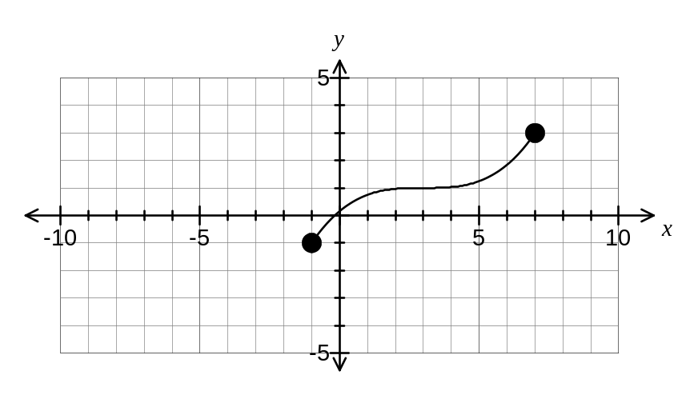
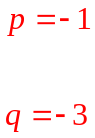

1 mark each correct value
Part (a) well done; Part (b) many had trouble with the horizontal dilation
(b) On the axes below sketch the graph of 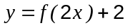. (2 marks)
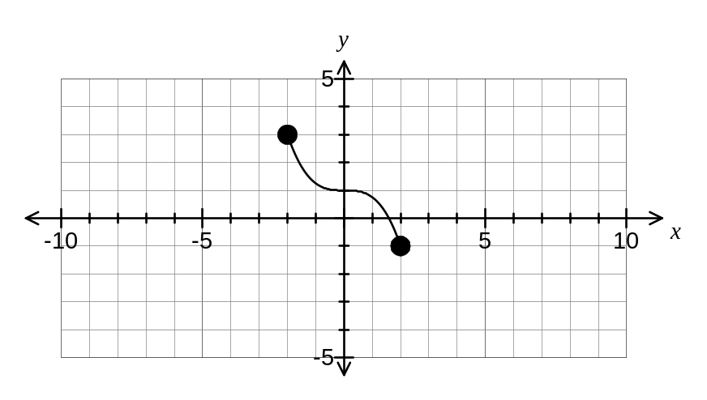
1 mark dilation, 1 mark translation

